Fat Prophets Global Contrarian Fund (FPC) announces a Disclosure pursuant to ASX Listing Rule 4.12
Dear Shareholders,
The estimated net tangible asset backing increased in July 2022 with pre-tax and post-tax NTA closing at $1.0056 and $1.0355. At the end of July, net cash for the Fund was 54.02%.
 | 31-July-2022 | 30-June-2022 | Change
Pre-Tax NTA | 1.0056 | 0.9964 | 0.92%
Post-Tax NTA | 1.0355 | 1.0534 | -1.70%

MARKET OUTLOOK AND PORTFOLIO PERFROMANCE
The past month has seen a strong rebound in US and global equities from heavily oversold conditions that persisted in June. Despite the rally, we continue to see challenging times ahead over at least the next few quarters for investors despite a “better than feared” US reporting season. We see further volatility directly ahead for financial markets despite the intense debate over whether the US stock market has made a final bottom.
We believe there is a good likelihood that US markets will be challenged again when the third quarter reporting season gets underway. Companies could soon start to grapple with falling sales prices and flattening revenues while at the same time be faced with high labour costs that would likely weigh on profits and margins. The 3rd quarter could therefore be characterised by downward earnings revisions.

Valuations are no longer cheap as they were back in June with the S&P500 now priced on a forward PE at c18x and vulnerable to downgrades. Whilst the first half of the year was one of the worst on record, the rebound underpinned by plentiful liquidity and short covering has mitigated the impact from the recent selloff. We are yet to also see capitulation on scale with previous US bear markets.

Meanwhile the Fed looks to be not done yet on interest rate hikes as evidenced by the overheating labour market, despite easing inflationary pressure. The bond market has diverged prominently from stocks with the yield curve now prominently inverted. In the past 50 years during every single cycle, recession has aways ultimately arrived when the curve has inverted. Volatility in bond markets also contrasts with the recent decline in the VIX.

Global growth is slowing in Europe and the UK which appears on the cusp of recession. We continue to see significant downside risks in China which might be underestimated currently by the markets. The property contagion has continued to spread and deepen, with consumers no longer responding as they have in the past to government stimulus. China’s slowdown comes amid persistent lockdowns and restrictive measures enforced by zero covid policies. Covid remains a key risk to China’s widely expected growth rebound over coming quarters.

While zero covid is expected to end when the Chinese leadership is finalised later this year, we have some doubts. China’s growth rate is continuously being buffeted by domestic policies and a global slowdown elsewhere. Geopolitical tensions are also on the rise once again with China at loggerheads with the US over Taiwan, and not likely to subside anytime soon.

We stay defensive in the portfolio and have prepared for volatility directly ahead but also potential opportunity. We have taken advantage of the recent rebound in stocks to further reduce risk and raise liquidity levels.

KEY METRICS
Gross Assets | Cash | Trailing 12 month  Dividend Yield (FF)
$39.99M | 54.02% | 8.33%

POSITIVE ATTRIBUTIONS
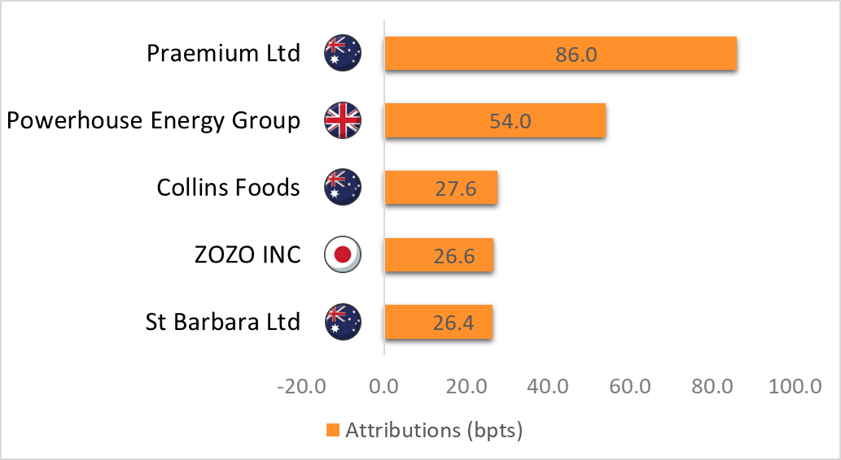
The largest positive attribution in July was from Praemium after the sale of the UK business facilitated a buyback and special dividend. Powerhouse rebounded from oversold levels, whilst Collins Foods rallied after solid profit results and a general market rotation back to growth. Zozo beat consensus profit estimates.

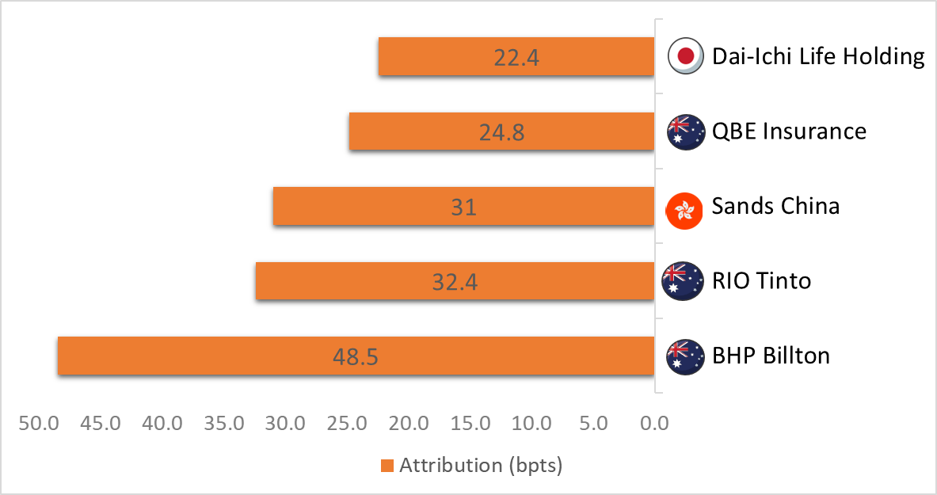
NEGATIVE ATTRIBUTIONS
Dai-Ichi Life and QBE Insurance weighed on the portfolio after bond yields fell pressuring investment income. Sands China was impacted by outbreaks of covid and ongoing restrictions. Rio Tinto and BHP traded lower on falling iron ore and copper prices.

TOP 10 HOLDINGS
Top 10 Holdings | Country | 31 July 2022
Collins Foods Ltd | Australia | 5.18%
Telstra Corporation Limited | Australia | 3.62%
QBE Insurance Group Limited | Australia | 3.44%
Sumitomo Mitsui Financial Group | Japan | 2.64%
BHP Billiton Limited | Australia | 2.61%
Beston Global Food Co Ltd | Australia | 2.37%
Fat Prophets Property | Australia | 2.35%
Powerhouse Energy Group PLC | United Kingdom | 2.34%
Global X Sil Min ETF | United States | 2.13%
Dai-ichi Life Holdings Inc | Japan | 2.02%
ASX: CKF | ASX: TLS | ASX:  QBE | TYO: 8316 | ASX: BHP | ASX: BFC | ASX: FPP | LSE: PHE | NYSE: SIL | TYO: 8750

Angus Geddes
Chief Investment Officer
Fat Prophets Global Contrarian Fund

